**REPORT**

|  |
| --- |
| **Experiment 1: Non-inverting Amp. vs Inverting Amp.** |

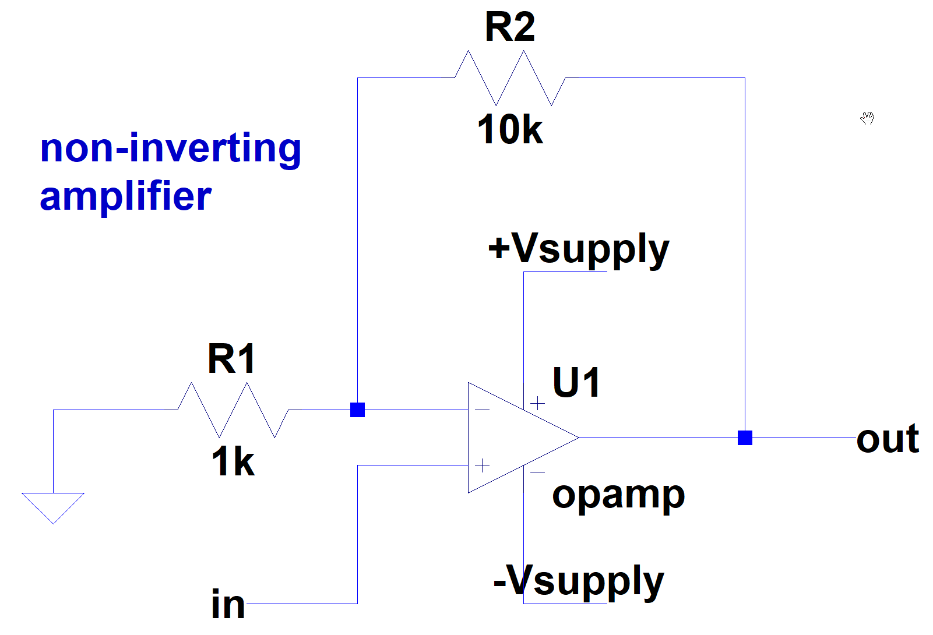

1.

When vin is connected to the ground, vout is 42.9m Volt.

**Question:**

**According to the equation: vout = Aopen (v+ - v-), the output voltage should be zero when v+ = v- = 0V.**

**Why is the output voltage still not equal to zero?**

After searching online, I found these 2 potential reasons:

1. Offset Voltage: Op-amps have a property known as **input offset voltage**. This is a **small, inherent voltage difference between the inverting and non-inverting inputs when no signal is applied**. This offset voltage can cause a small output voltage even when the inputs are at the same voltage potential.
2. Input Bias Current: Op-amps also have **input bias currents.** These are **small currents that flow into or out of the input terminals, even when no input voltage is present.** The input bias currents can cause a voltage drop across input resistors and result in a small output voltage.

LTspice Simulation Result:

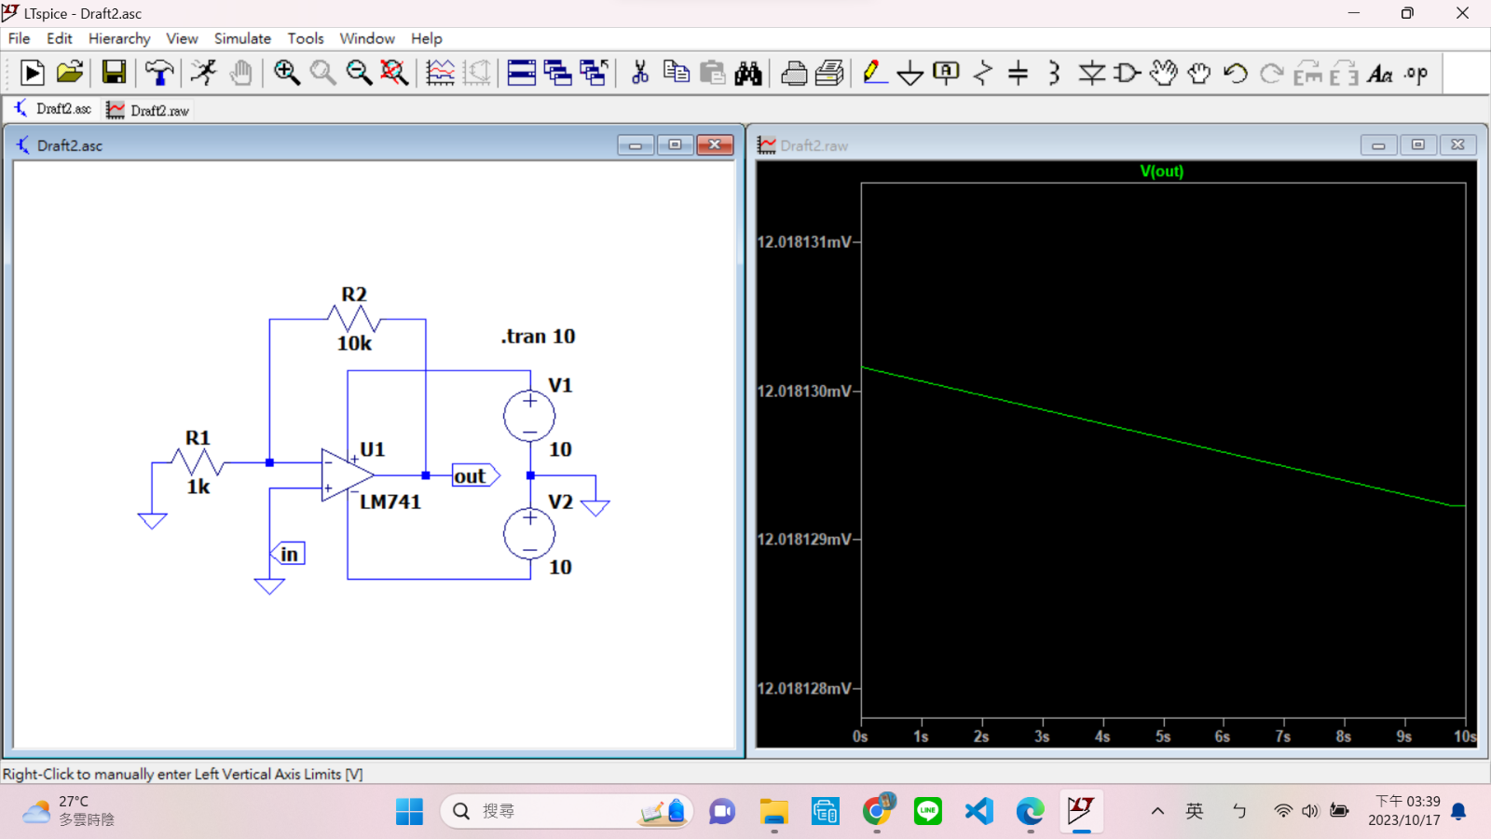

Oscilloscope Result:

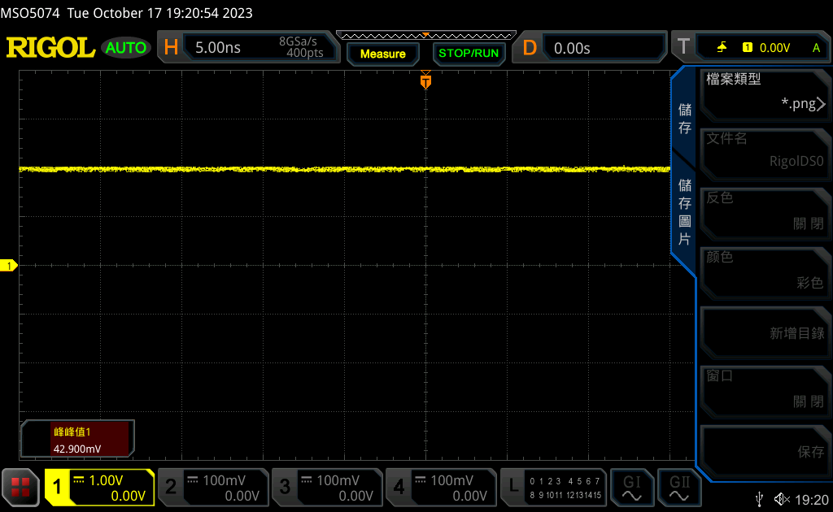

2.

LTspice Simulation Result:

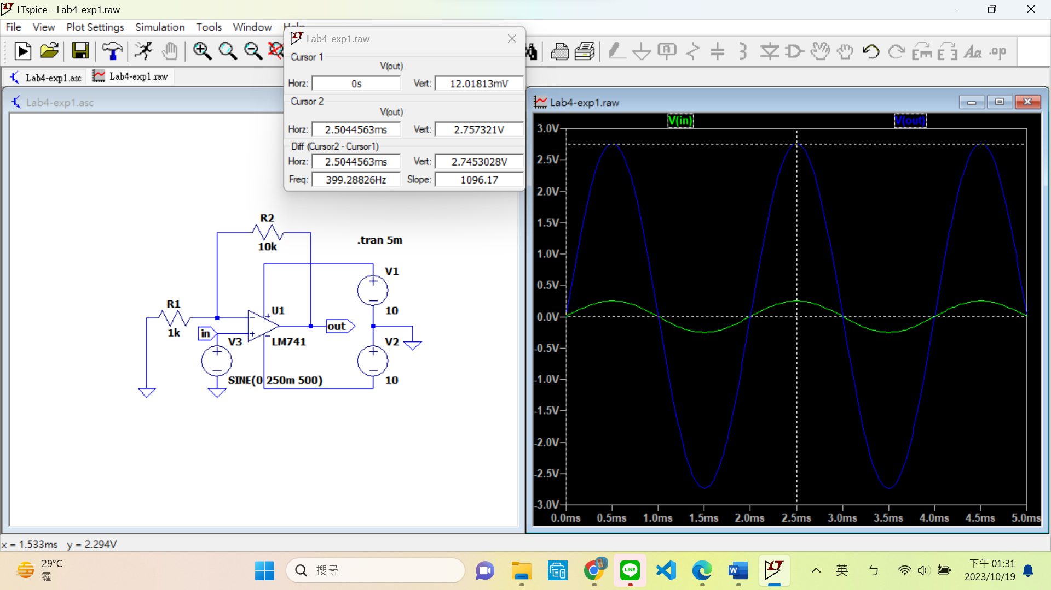

vin and vout waveform in the same graph

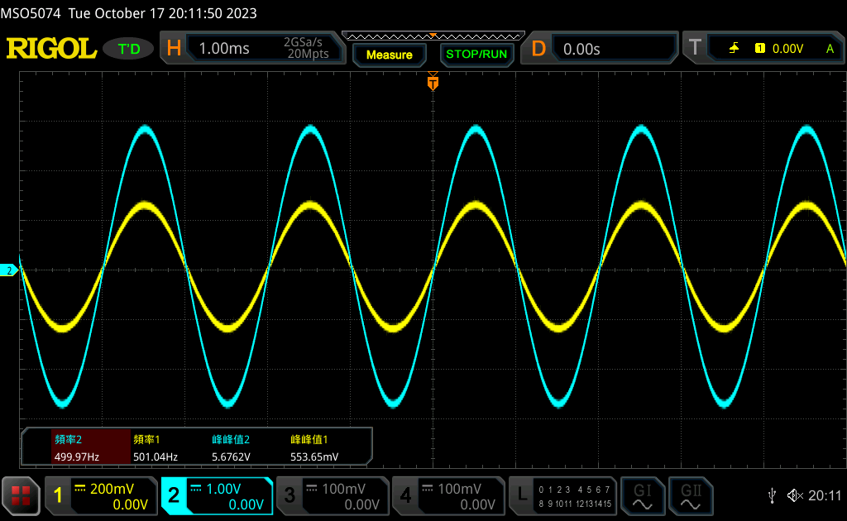

|  |  |  |  |
| --- | --- | --- | --- |
| vin,pp (V) | vout,pp (V) | Measured voltage gain; Av (V/V) | Theoretical voltage gain; Av (V/V) |
| **0.553** | **5.676** | **10.264** | **11** |

**Equation:**

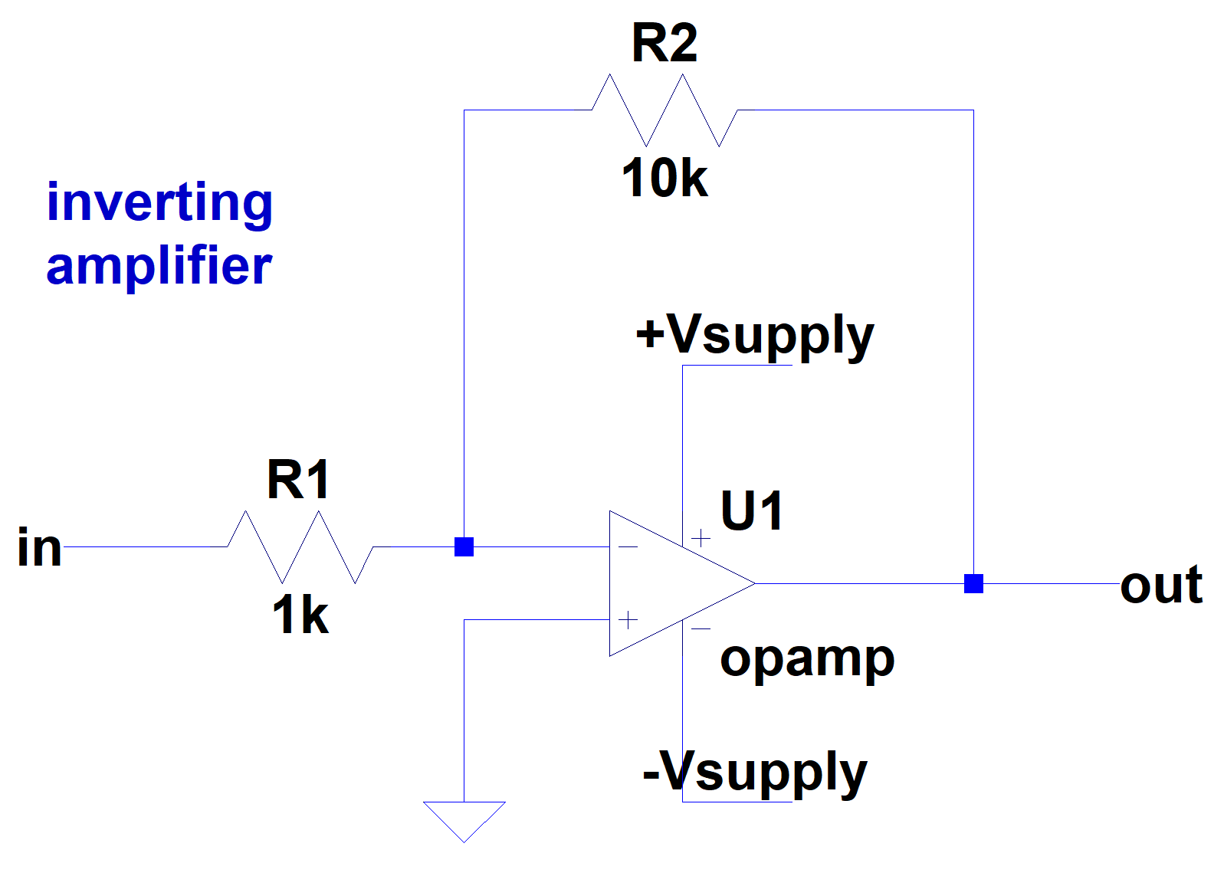

3.

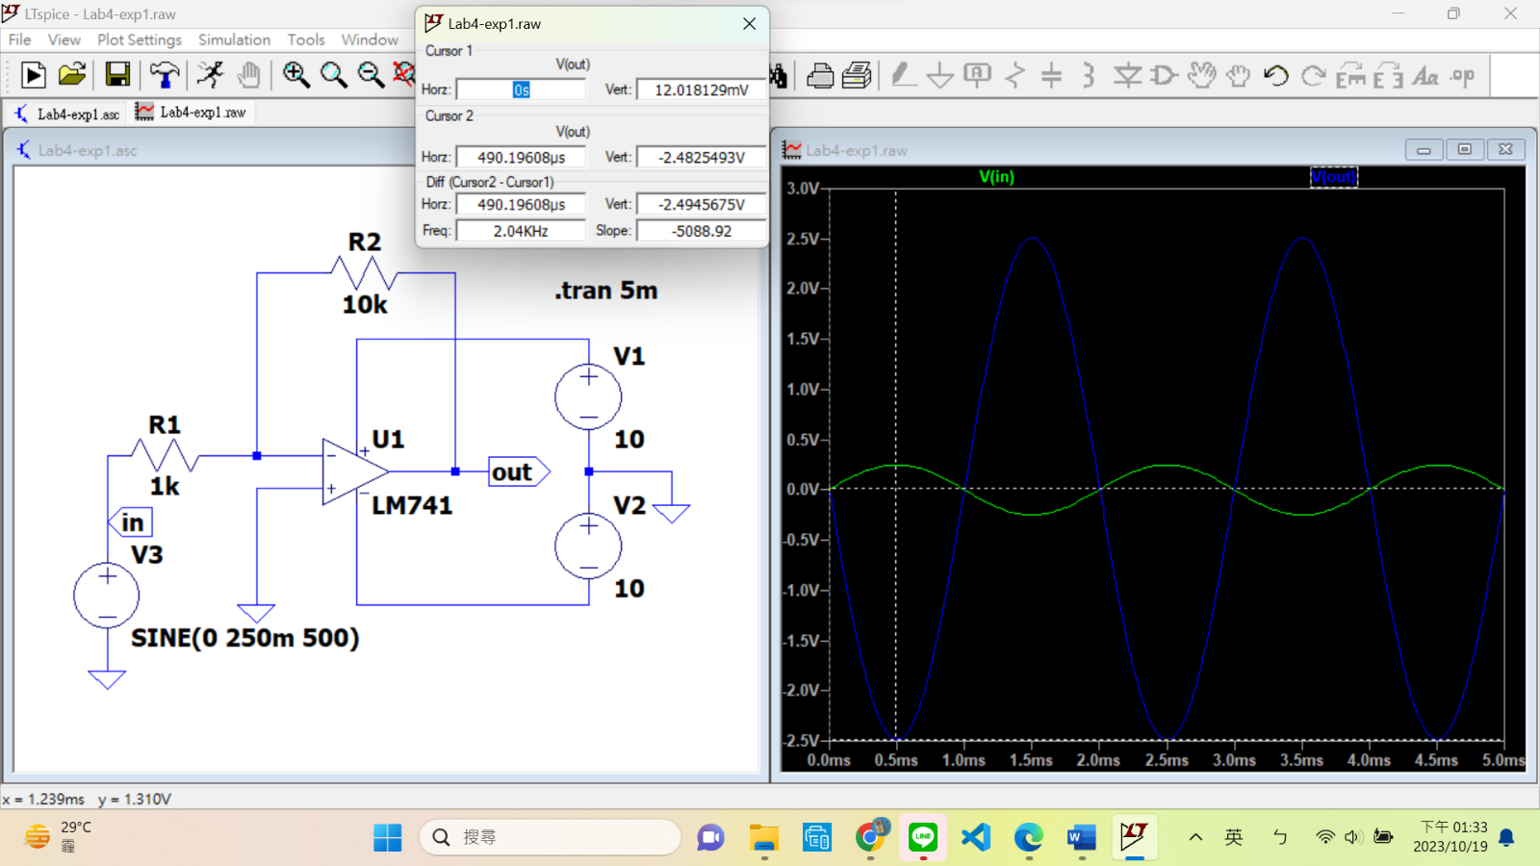LTspice Simulation Result:

vin and vout waveform in the same graph

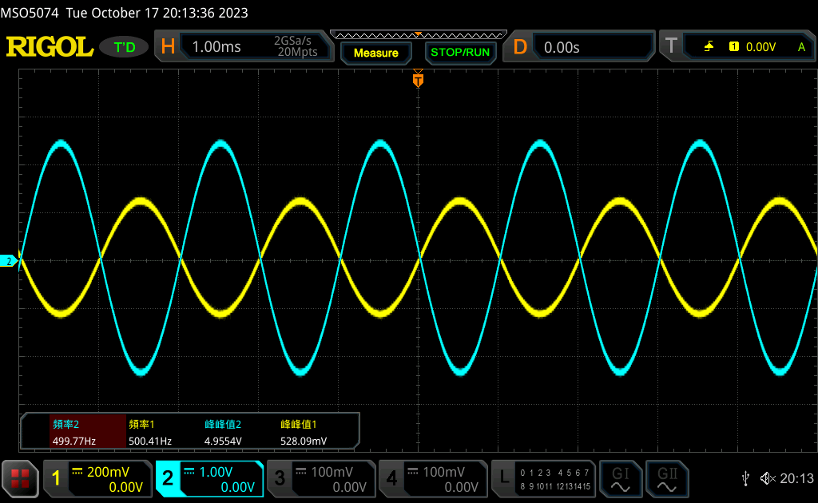

|  |  |  |  |
| --- | --- | --- | --- |
| vin,pp (V) | vout,pp (V) | Measured voltage gain; Av (V/V) | Theoretical voltage gain; Av (V/V) |
| **0.528** | **4.955** | **9.384** | **10** |

**Equation:**

4.

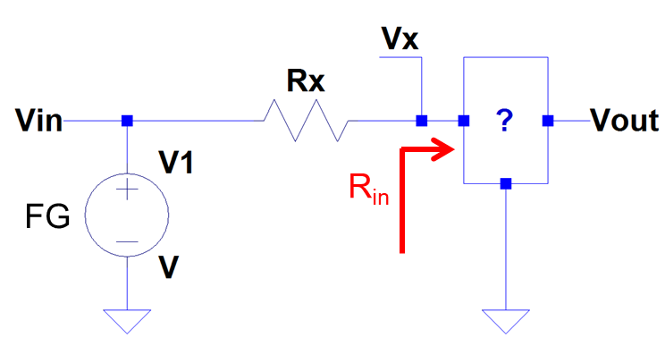

The input impedance of the inverting amplifier is 956 Ohm.

|  |
| --- |
| **Experiment 2: Weighted Adder** |

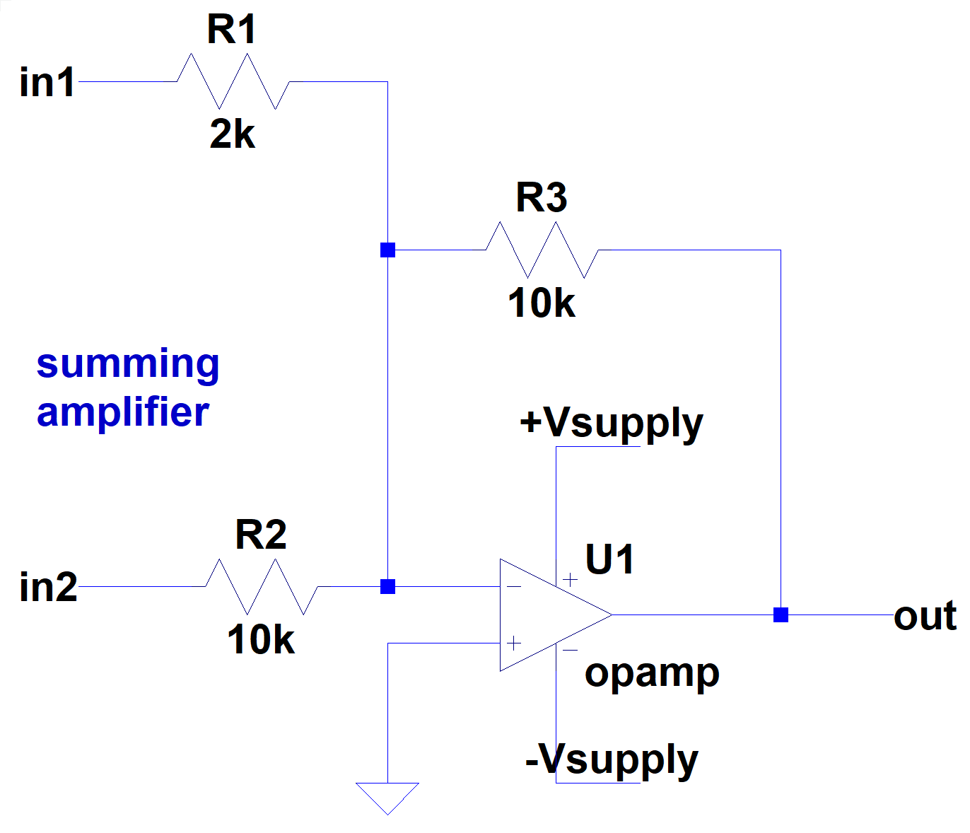

|  |  |  |  |
| --- | --- | --- | --- |
| vin1,pp (V) | vin2,pp (V) | Measured vout,pp (V) | Theoretical vout,pp (V) |
| **0.97** | **0.295** | **0.972** | **0.8** |

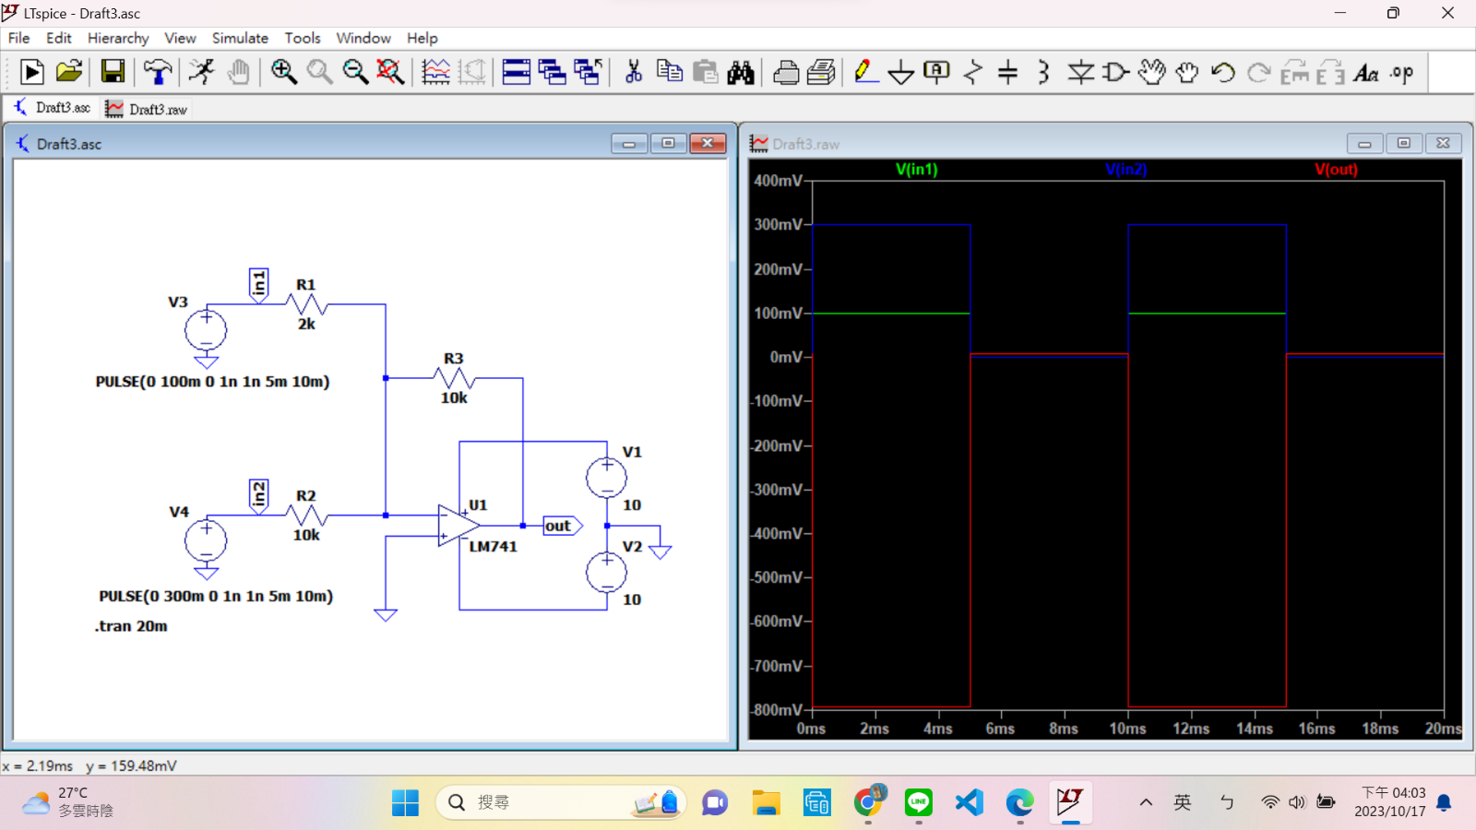LTspice Simulation Result:

in1 & in2 waveform

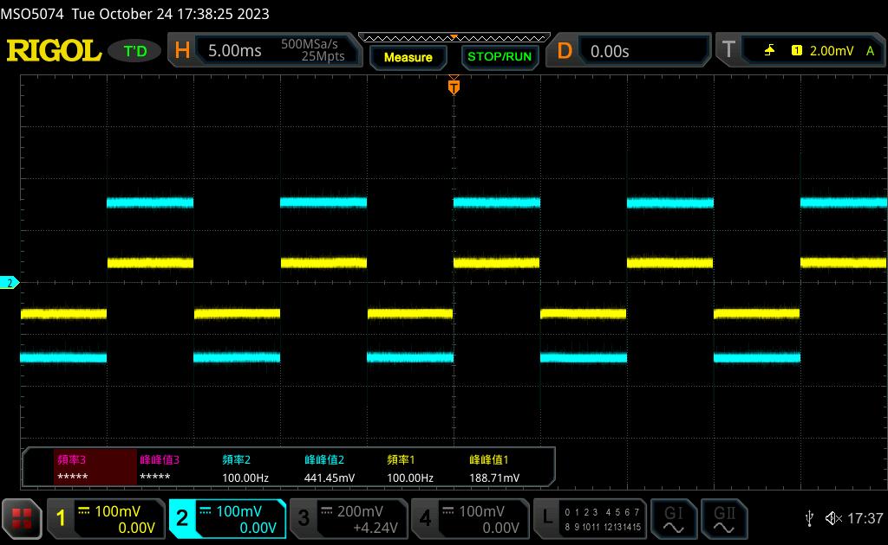

in1 & out waveform

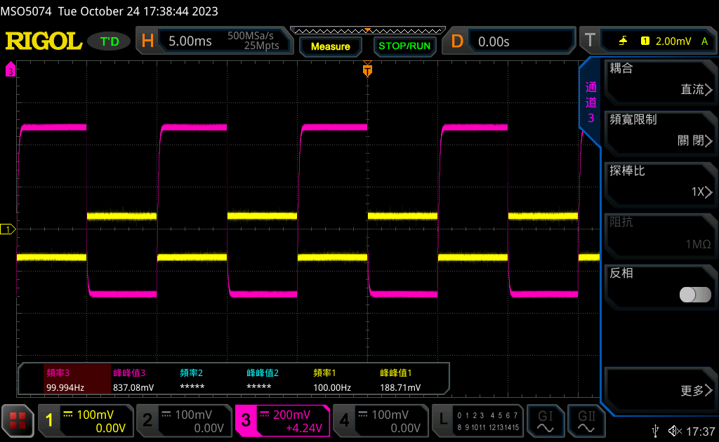

in2 & out waveform

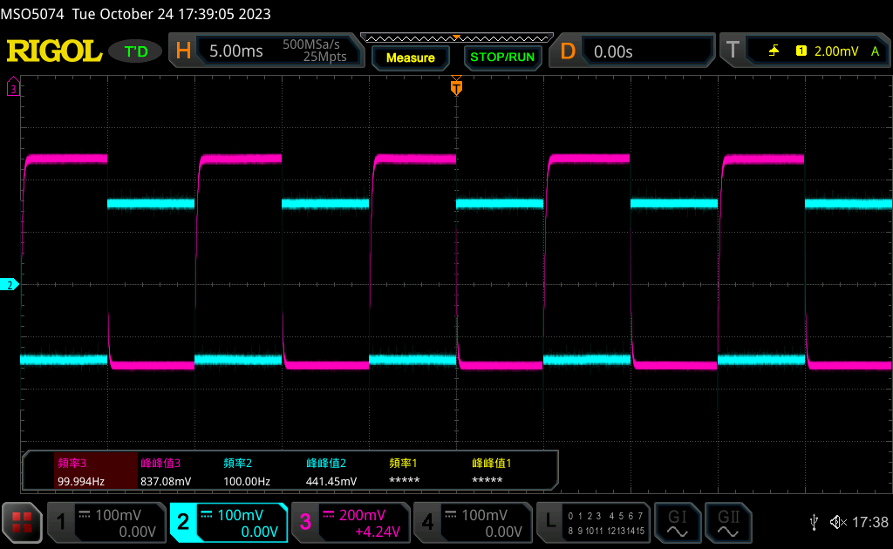

Our oscilloscope, the MSO5074 supports 4 inputs. Therefore, I took a screenshot of all 3 signals together.

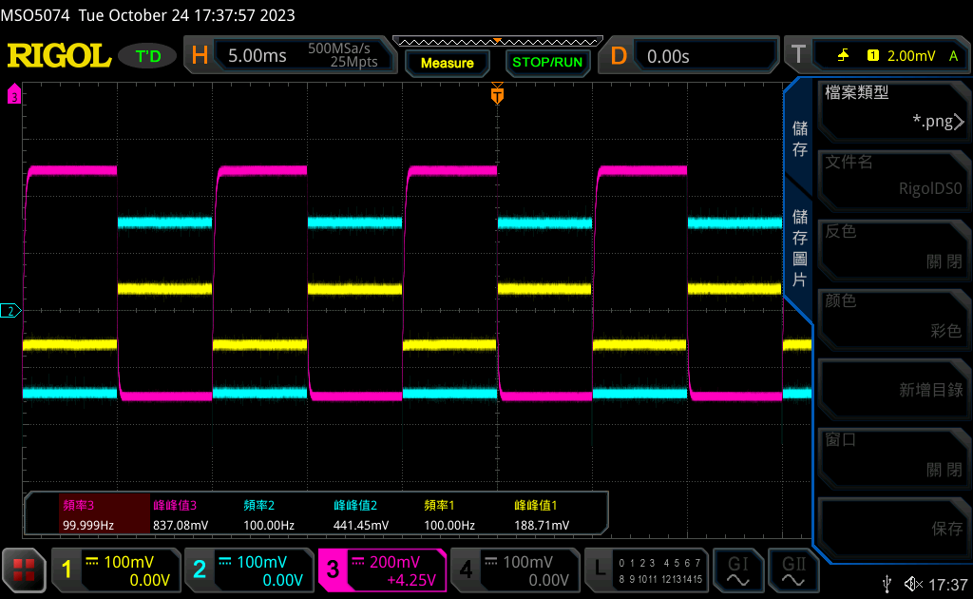

**Question:**

**Please derive the equation for vout. Use symbol (vin1, vin2, R1, R2, R3, etc.) to represent.**

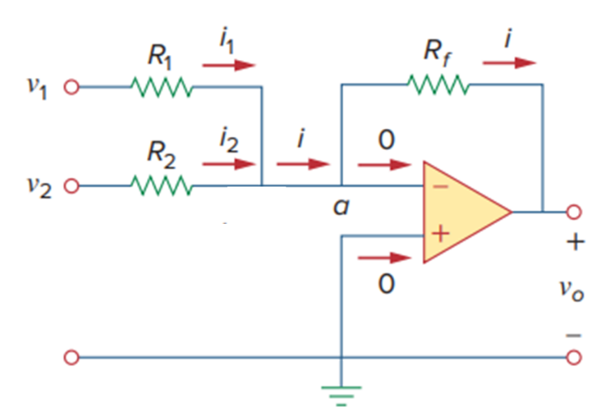

***Substitue into the equations above and we get:***

|  |
| --- |
| **Experiment 3: Voltage Follower** |

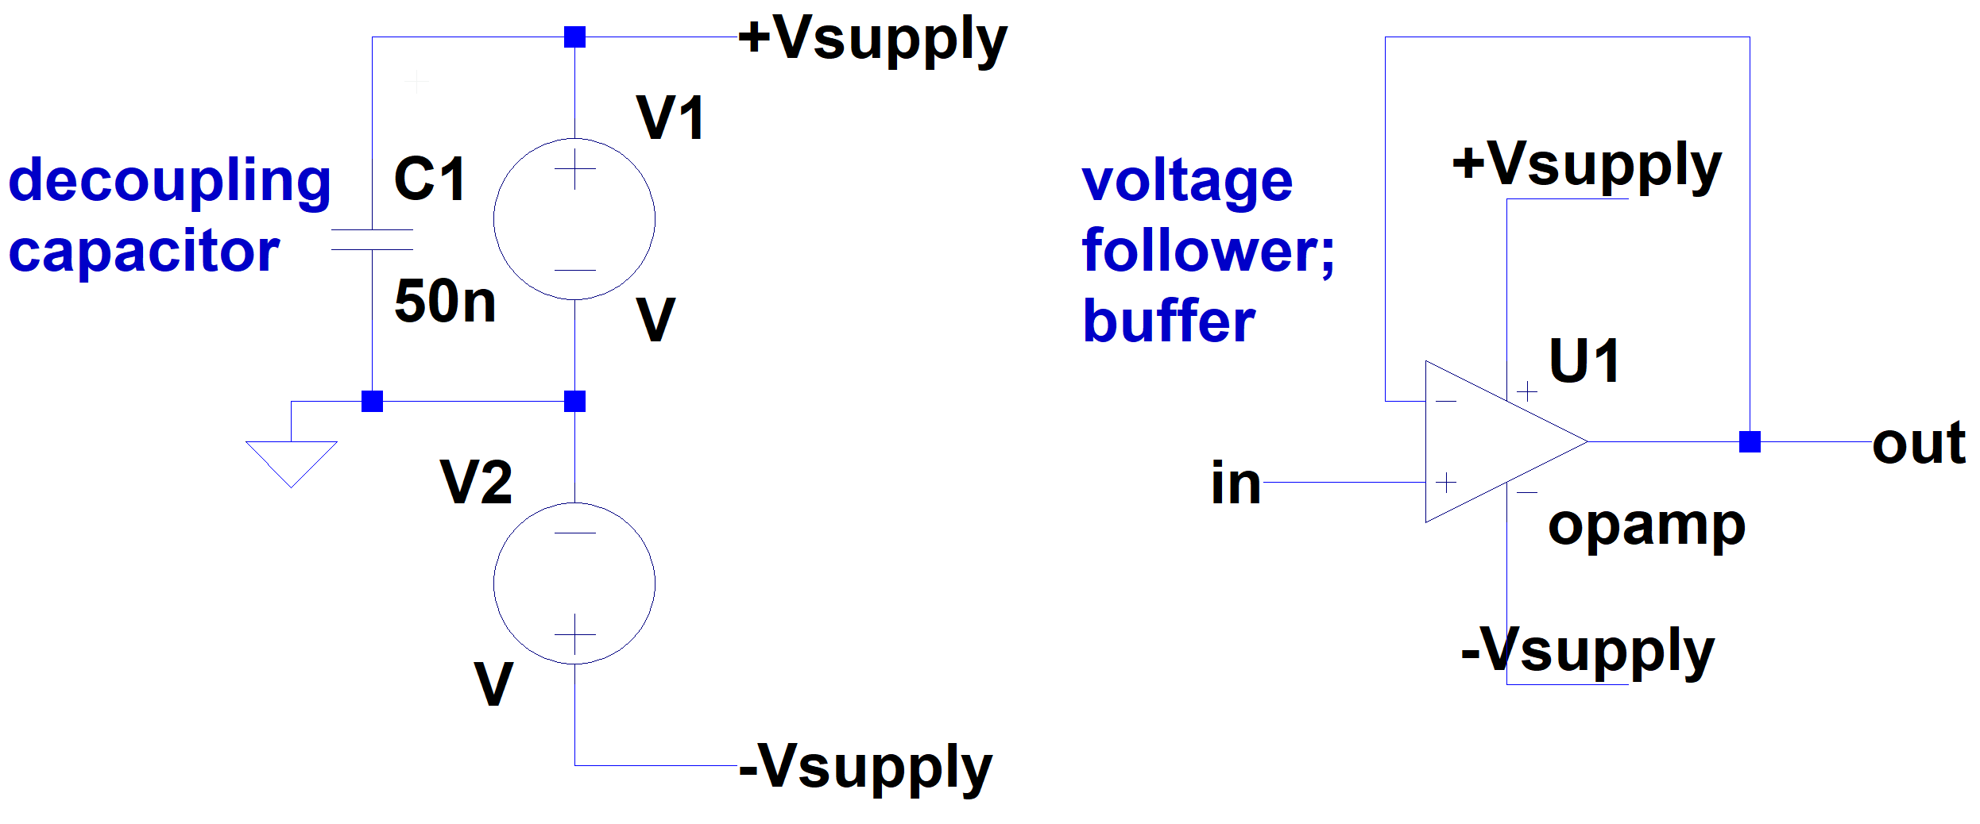

2.

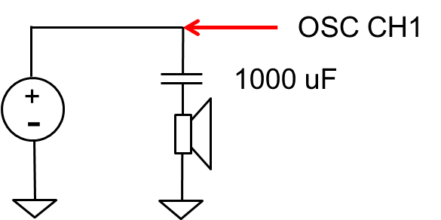

waveform for FG + OSC + Speaker

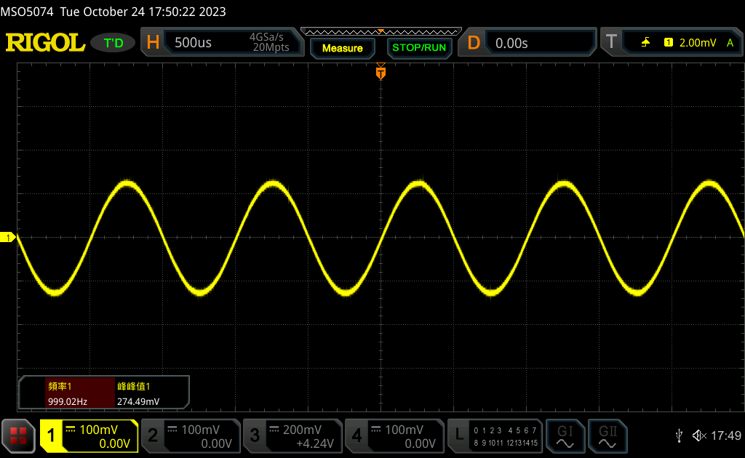

3.

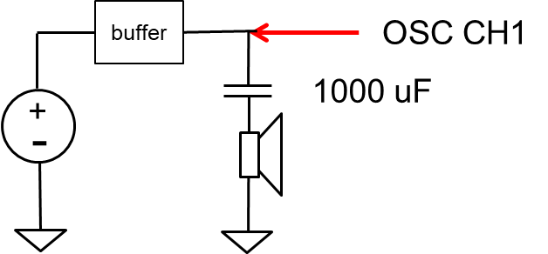

waveform for FG + Buffer + OSC + Speaker

Result from partially fried op amp

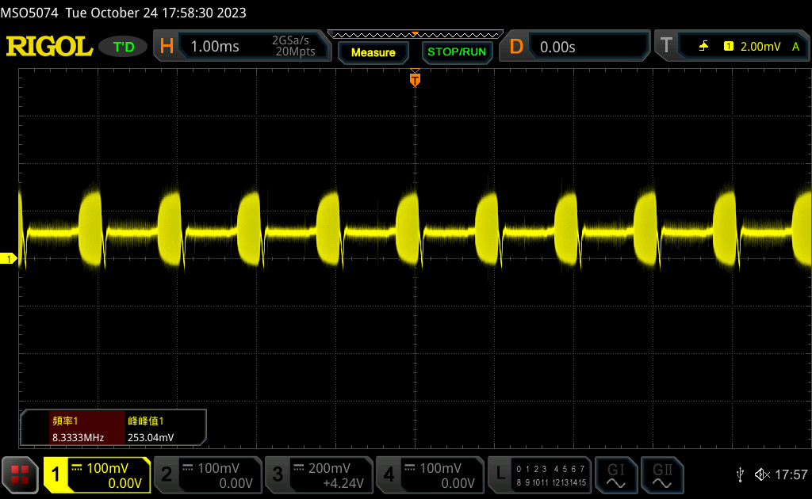

**Reflection:**

I actually attempted this experiment again, this week, on the 24th. I’ve seen what other people’s waveforms on this part look like and mine looks nothing like those. After retrying, I got the same “incorrect” result. As later pointed out by the senior TA, there’s something wrong with my op amp. When gain is 1 V/V on the op amp, there should be minimal offset voltage. **Passing a sine wave with 0 offset on the FG through the op amp should give a signal that has almost no observable offset on the oscilloscope. However, my wave had considerable offset.** I must have accidentally fried it previously by giving it too much current from the power supply. This half-broken op amp can still amplify the input voltage, producing correct results for exp2, but as we can see here in exp3, it leads to problems in certain cases.

Had I not approached the senior TA and raised my questions, there would potentially be dire consequences in future experiments. **I very much appreciate the fact that she helped me find this problem. I wouldn’t have known how to tell whether an op amp is damaged or not if not for her.** I suppose this is the beauty of **hands-on experiment**. **Certain things like this can’t really be learned from textbooks.** I’ll be sure to keep an eye on my power supply’s current when using my new op amp, which I have yet to buy from an electronics components store.

Result from fully functional op amp

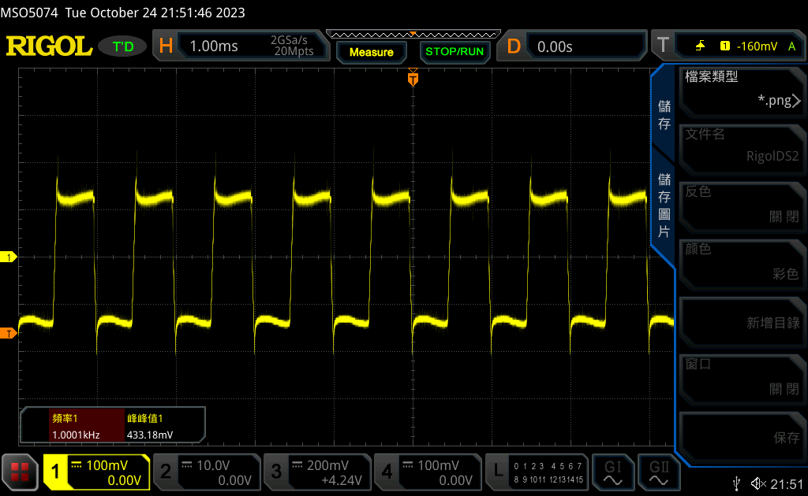

**Question:**

**Are there any differences between these two connections?**

**Without** a buffer, the signal’s **amplitude is smaller and we can’t really hear it from the speaker**.

After **adding the buffer**, the signal’s **amplitude gets increased and we can hear a much louder sound coming from the speaker.** However, the signal that passes through the buffer is **no longer a sine wave. It has been distorted to what resembles a square wave.**

**Can you explain the phenomena? Hint: voltage divider**

An op-amp buffer has a **very high input impedance()**, which means it presents a minimal load to the preceding stage or signal source. This **prevents the source from being affected by the load it is driving**. The high input impedance ensures that the voltage at the input terminal is minimally disturbed by the connected circuit.

The **low output impedance()** of the op-amp buffer ensures that it can **supply a relatively large current to the next stage without affecting the voltage.** This is particularly useful when connecting the output of the op-amp to other circuits, as it helps maintain a stable voltage even when the next stage has a lower input impedance.

When you connect a signal source to a load, the load can affect the signal by causing a voltage drop. An op-amp buffer isolates the source from these loading effects and **preserves the voltage level**. This ensures that the **source voltage remains stable**.

**Reference:**

1. Texas Instrument-Understanding Basic Analog – Ideal Op Amps

<https://www.ti.com/lit/an/slaa068b/slaa068b.pdf?ts=1698194581497&ref_url=https%253A%252F%252Fwww.google.com%252F>

1. All About Circuits- Op Amp Practical Considerations:

<https://www.allaboutcircuits.com/textbook/semiconductors/chpt-8/op-amp-practical-considerations/>